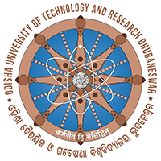 | ODISHA UNIVERSITY OF TECHNOLOGY AND RESEARCH  (Techno Campus, Ghatikia, P.O.-Mahalaxmi Vihar  BHUBANESWAR-751029, ODISHA, INDIA
No. 2100 /OUTR Date: 25/06/2025
Walk-in Interview

Odisha University of Technology and Research (OUTR), Techno Campus, Ghatikia, Bhubaneswar invites applications from interested retired employees to work as Consultants/office assistants on contractual basis on a fixed remuneration basis. The interested candidates must not have attained the age of sixty-four years as on the date of interview which is going to be held on 03.07.2025 in OUTR.
The candidate must have adequate knowledge in Establishment matters like Record Keeping, File Maintenance, Legal Matters, Drafting, and Noting etc. He must possess knowledge, skill and experience to work with Computer to perform official duties.
On the day of the Walk-in interview he must bring with him:
- His complete Bio-data containing his service records i.e; date of birth, date of retirement etc.
- A copy of retirement order from the department/office/institution he last served in.
- One recent passport size photo
- No TA/DA is admissible for the interview
The Authority reserves the right to cancel part or entire process of the walk-in interview without assigning any reason thereof.

Sd/-
REGISTRAR

